April monthly report
โครงการ P2451496 งบยุทธ_CCU68_การต่อยอดและพัฒนาเทคโนโลยี Carbon capture and utilization (CCU) ที่มีความต้องการจากภาคอุตสาหกรรม และขับเคลื่อน National CCUS Alliance ร่วมกับเครือข่ายพันธมิตร
Sothearoth Heng
Under the supervision of
Dr. Pongkarn Chakthranont
ใบสั่งจ้างเลขที่ PO25005060
จ้างเหมาพัฒนางานจ้างพัฒนาการขยายขนาดเซลล์ไฟฟ้าเพื่อการผลิตแก๊สสังเคราะห์จาก CO2 เชิงเคมีไฟฟ้า
งวดที่ 1: 1 เมษายน 2568 – 31 เมษายน 2568
……..........................................................
Dr. Pongkarn Chakthranont

- To-do list for April
- Optimization of 25cm² CO₂ electrolyzer operating condition:
  - Influence of catalyst mass loading on the overall cell performance
  - Influence of different total CO₂ flow rates on the overall cell performance
- Stability test of Ni0.25SAC under diluted 15%CO₂/85%N₂ and pure CO₂ conditions using 5cm² CO₂ electrolyzer
- Experimental Procedure
Membrane electrode assembly set-up
A 25 cm² MEA electrolyzer was used to evaluate the CO2RR performance under modulated operating conditions. The Ni foam (5.4 x 5.4 cm), bipolar membrane (BPM, 6 x 6 cm), and NiSAC (5 x 5 cm) were employed as the anode, membrane, and cathode electrode, respectively. The MEA was assembled and tightened with a torque force of 35 inch-lbs. 200 ml of 1M KOH was recirculated and used throughout the experiment as the anolyte at 25 ml/min. The humidified CO₂ gas stream was introduced into the cathodic inlet with a total CO₂ flow rate of 150 ml/min. Prior the test, the electrochemical impedance spectroscopy (EIS) and Cyclic voltammetry were measured. Meanwhile, the cathodic outlet was directly injected into an online gas-chromatography for gas products analysis.

- Results
Influence of applied current density on CO2RR performance
Studying the impact of the applied current density in CO₂ electrolysis is crucial as it directly influences the product selectivity, energy efficiency, and overall system performance. The figure 1. Illustrates the CO₂ electrolysis under a pure CO₂ at 100 – 200 mA/cm². The overall system enables to sustain a high CO selectivtiy with FE(CO) > 91% at applied current density range of 100 – 200 mA/cm² with a rising overpotential as current density increases from 3.65V at 100mA/cm² to 6.37V at 200mA/cm². Furthermore, it is worth noting that once further ramping the current density to 200mA/cm², we observed a significant increase in cell voltage with a marginal drop of FE(CO) which could be attributed to either cell failure or electrode degradation at such a high current density.
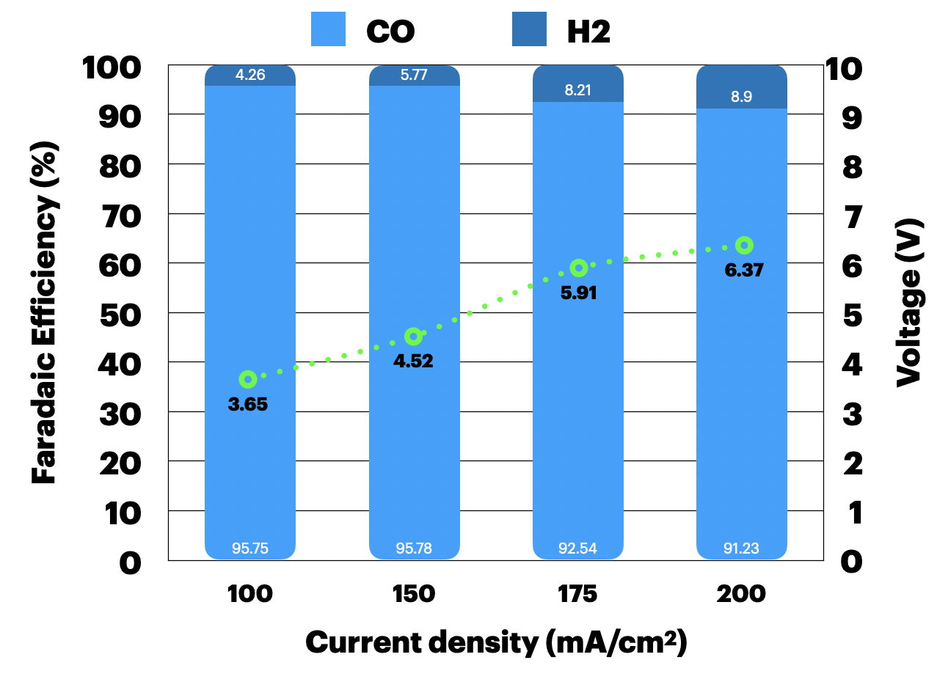
Figure 1. CO₂ electrolysis of a zero-gap MEA (Ni foam/BPM/NiSAC) under a pure 300ml/min CO₂ and 25ml/min of 1M KOH at 100 – 200 mA/cm²

Influence of catalyst mass loading on CO2RR performance
In order to evaluate the effect of catalyst layer (CL) thickness on the overall performance of the NiSAC, here we conducted the CO2 electrolysis under a pure CO₂ condition at 100mA/cm² with different NiSAC mass loading of 1.6, 2.1, and 2.5 mg/cm². As depicted in Fig. 2, the overall cell performance in terms of CO selectivity and cell voltage exhibited similar results at different mass loading, thereby showing a slight impact of the catalyst mass loading on the cell performance. A mass loading of 2.1 mg/cm² provides the best balance of high CO selectivity and energy efficiency under the given experimental conditions. Increasing the mass loading beyond this point (to 2.5 mg/cm²) leads to a slight decrease in CO selectivity and an increase in voltage, which may indicate mass transport limitations at higher loadings. Based on these results, a NiSAC with mass loading of 1.8±0.3 mg/cm² will be selected for further investigation.
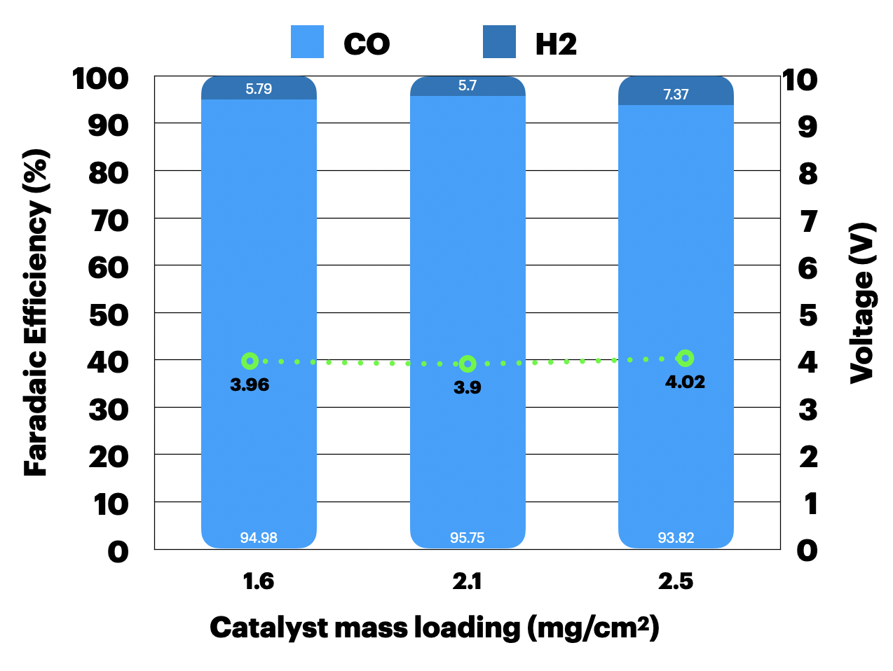
Figure 2. CO₂ electrolysis of Ni0.5SAC with m/l of 1.6, 2.1, and 2.5 mg/cm² under a pure 300ml/min CO₂ and 25ml/min of 1M KOH at 100 mA/cm²

Influence of different CO₂ flow rates on CO2RR performance and single-pass CO₂ utilization (SPU)
Understanding the impact of CO₂ supply on CO selectivity and SPU is critically important for experimental design aimed at achieving maximum CO selectivity while maintaining high carbon efficiency. Figure 3 illustrates the influence of CO₂ supply on both CO selectivity and SPU. Across all CO₂ flow rates, the system consistently achieved high FE(CO) > 94%, with a maximum SPU of 36% at a CO₂ flow rate of 50 ml/min. This highlights a trade-off, where lower CO₂ flow rates offer significantly higher single-pass CO₂ utilization while preserving product selectivity.
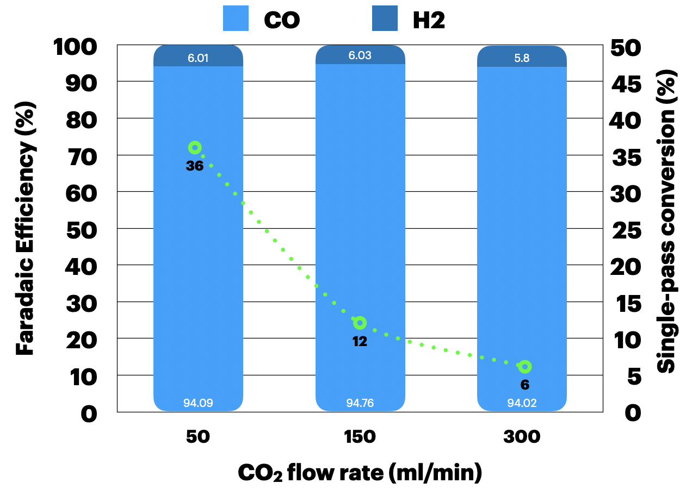
Figure 3. CO₂ electrolysis of Ni0.5SAC under a pure 50, 150, and 300ml/min CO₂ and 25ml/min of 1M KOH at 100 mA/cm²

Long-term CO₂ electrolysis of NiSACs (0.25, 0.5, 1, and 2) under diluted and pure CO₂ conditions at 100mA/cm²
Figure 4 illustrates the long-term CO₂ electrolysis for CO production during CO₂ electrolysis, utilizing various nickel single-atom catalysts (NiSACs): Ni0.25SAC, Ni0.5SAC, Ni1SAC, Ni2SAC, and Acid-Ni0.5SAC. These catalysts were tested in a diluted gas mixture of 15%CO₂/ 85% N₂ at a constant current density of 100 mA/cm². Among the tested catalysts, Ni0.25SAC exhibited the most stable and sustained performance, consistently surpassing 80% CO FE throughout an extended 80-hour operation. Ni0.5SAC initially achieved a higher FE (~88%) but gradually declined over time. Ni1SAC, Ni2SAC, and Acid-Ni0.5SAC exhibited similar outcomes to Ni0.5SAC, commencing with a higher initial FE(CO) (~90%) before experiencing rapid losses in CO selectivity within the first 10 hours.

Key Observations:
Effect of Nickel Loading
Lower Loadings (Ni0.25SAC and Ni0.5SAC): These catalysts maintain higher efficiencies over time compared to higher loadings. Ni0.25SAC, having the lowest nickel content, exhibits the best performance, maintaining efficiency near 90% over 80 hours. Ni0.5SAC shows a slight decline in terms of selectivity but still maintains it above 65% over 35 hours.
Higher Loadings (Ni1SAC and Ni2SAC): For higher loadings, the increased nickel content seems to compromise long-term stability, as these catalysts suffer rapid and significant FE(CO) drops early in the process.
Impact of Acid Treatment: The acid-treated Acid-Ni0.5SAC initially performs like Ni0.5SAC, with a slightly higher FE(CO), but its efficiency declines more rapidly. This suggests that acid treatment negatively impacts long-term performance, possibly by increasing the catalyst's surface hydrophilicity, which leads to rapid GDE flooding.

Figure 5 presents the long-term CO₂ electrolysis performance of Ni0.25SAC and Ni0.5SAC catalysts at a current density of 100 mA/cm². Ni0.25SAC consistently maintains a high and stable CO selectivity, with an average FE(CO) approx. 94% over the 90-hour operation. This demonstrates exceptional selectivity and durability. In contrast, Ni0.5SAC initially exhibits comparable performance with a slightly higher FE(CO) approx. 97% but gradually declines after 70 hours. Furthermore, Ni0.25SAC operates at a lower and more stable cell voltage than Ni0.5SAC, reflecting increased energy consumption and diminished system stability over time. These findings underscore Ni0.25SAC as the more efficient and stable catalyst for sustained CO₂ electrolysis under both diluted 15%CO2/85% and pure CO₂ conditions.

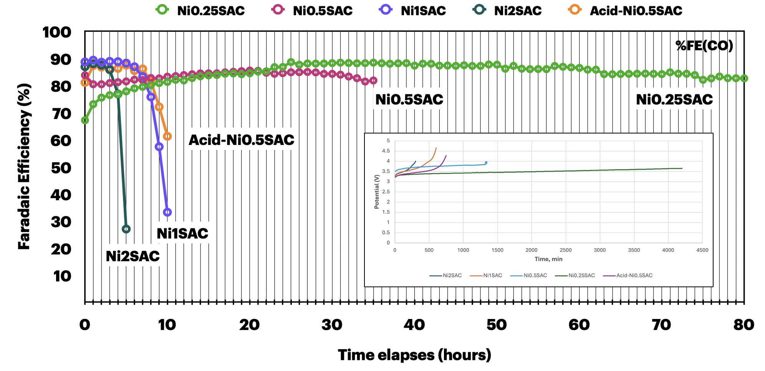
Figure 4. CO₂ electrolysis of Ni0.25SAC (m/l = 1.8±0.1mg/cm²) under 100ml/min of 15%CO₂/85%N₂ and 8ml/min of 0.25M KOH at 100 mA/cm²
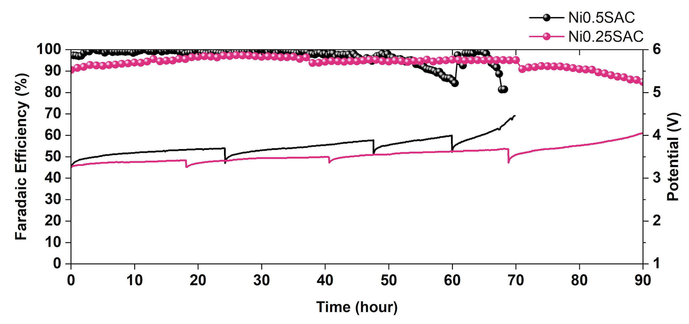
Figure 5. CO₂ electrolysis of Ni0.25SAC and Ni0.5SAC (m/l = 1.8±0.1mg/cm²) under a pure 150ml/min CO₂ and 8ml/min of 0.25M KOH at 100 mA/cm²
- Upcoming tasks
- 25cm² electrolyzer - Stability of Ni0.25SAC (m/l = 1.8±0.2mg/cm²) with 0.25M - IrO₂ under 300ml/minCO₂ at 100mAcm²
- 25cm² electrolyzer - Stability of Ni0.25SAC (m/l = 1.8±0.2mg/cm²) with 0.25M - IrO₂ under 30ml/minCO₂ at 100mAcm²

